f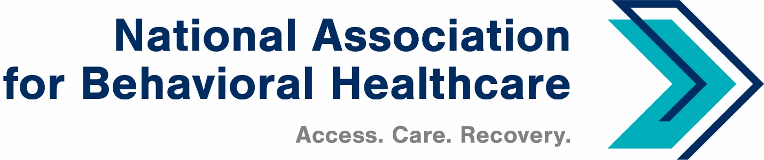
NABH Executive Committee Call
Monday, May 9, 2022
Minutes

Roll Call
Present: Members: Matt Peterson, Board Chair; Jameson Norton, Mark Covall,
Pat Hammer, Eric Kim, Eric Paul

Staff: Shawn Coughlin, Kirsten Beronio, Maria Merlie, Julia Richardson,
Sarah Wattenberg, Emily Wilkins, Jessica Zigmond

Absent: Frank Ghinassi, John Hollinsworth, Francis Sauvageau, Harsh K. Trivedi

- Minutes Approval: April 11 Executive Committee Call
A motion was made and seconded to approve the April 11 minutes. There were no questions and members approved the minutes unanimously.

- Wit v. UBH Amicus Brief: Supporting Activities (Attachment)
Shawn said that the Federation of American Hospitals and the American Hospital Association have joined the Amicus Brief along with the other provider groups that have joined. NABH is sponsoring this amicus brief and organizations have until May 16 to sign on.

Shawn said the original brief he shared has been revised to include the practical implications that this ruling will have and how it undermines the Mental Health Parity and Addiction Equity Act of 2008.

Shawn added that NABH expects U.S. Health and Human Services Secretary Becerra and U.S. Labor Secretary Martin Walsh, along with four state attorneys general in the states that follow ASAM criteria, to sign the amicus brief.

- Parity Webinar with HHS Secretary Xavier Becerra
Shawn reported that he participated in a parity webinar with HHS Secretary Becerra and other healthcare officials on April 26. NABH co-sponsored the webinar.

The recorded webinar is available in the April 29th edition of CEO Update at www.nabh.org.

- IPF-PPS Proposed Rule
Shawn said the rule for 2023 did not include substantive changes but did include technical analysis for potential future changes. NABH has engaged an external payment expert to determine if the technical analysis from the Centers for Medicare & Medicaid Services is accurate.

- Workplace Violence: HHS Meeting
Shawn said Sen. Tammy Baldwin (D-Wis.) is looking for a Republican sponsor to “hotline” a House-passed bill about workplace violence. Hotline is a procedural measure used to achieve unanimous consent in the Senate.

Shawn said NABH has met with representatives from the Labor Department’s Occupational Safety and Health Administration and sent several letters to OSHA regarding workplace violence in the behavioral healthcare industry.

Shawn also spoke with Rachel Pryor, advisor to HHS Secretary Becerra, about NABH’s concerns and recommendation that HHS contact OSHA to develop a stakeholder process to discuss this. Shawn reminded EC members that OSHA has recommended workplace-violence prevention measures that NABH does not support, such as restraint, medication, armed guards at a facility’s front door, and positioning employees stand behind plexiglass windows.

- Surprise Billing Final Rule
Shawn said NABH expects the Biden administration to re-release a surprise billing final rule. There was a lot of provider backlash when the rule was released initially. The administration has re-visited the issue and is expected to release a new rule within weeks.

- Legislative Outlook
Shawn reported that the last two months have been very active on Capitol Hill. The House Energy & Commerce Committee has released a Substance Abuse and Mental Health Services (SAMHSA) re-authorization bill and expect to release others to improve mental health and substance use disorder (SUD) services.

Senators Chris Murphy (D-Conn.) and Bill Cassidy, M.D. (R-La.) of the Senate Health, Education, Labor & Pensions (HELP) Committee are sponsoring a SAMHSA reauthorization bill that includes two provisions NABH supports: 1) state dollars for parity-implementation efforts, and 2) permission to allow for-profit organizations to access grants. Sen. HELP Committee Chair Murray has not yet released her chairman’s mark, a term used to describe to the legislative prerogative of the committee’s chairperson.

- Regulatory Activity
NABH Director of Quality and Addiction Services Sarah Wattenberg reported that the motivational incentives policy group wrote a letter to HHS Secretary Becerra to advise SAMHSA to remove its grant limits of 75.00 for contingency-management incentives. This would align the grant requirements with a new Office of Inspector General (OIG) opinion. The letter has support from 25-30 organizations.

The White House Office of National Drug Control Policy (ONDCP) released its methamphetamine plan that highlights the use of contingency management as an evidence-based practice for treating stimulant use disorder. Other highlights include the inclusion of harm reduction for the first time. Please read the May 9 NABH Alert for more details.

- Annual Meeting

Registration/Promotion:
NABH Director of Communications Jessica Zigmond reported that the 2022 Annual Meeting planning is going very well. NABH’s Exhibitors/Sponsors and advertising in the guide are ahead of where NABH was this time last year. In addition, NABH is receiving registrations daily and continues to promote the meeting through weekly Annual Meeting Alerts and on social media.

Speakers:
Jessica also reported that NABH has confirmed two more speakers since the April EC call: ONDCP Director Rahul Gupta, M.D., M.P.H., M.B.A., FACHE and John Palmieri, M.D., senior medical advisor at SAMHSA and director for the 988 and behavioral health crisis coordinating office. Dr. Palmieri will talk about the upcoming launch for the 988 behavioral health crisis hotline.

- Adjournment
Shawn adjourned the call at 3:29 p.m. ET.

