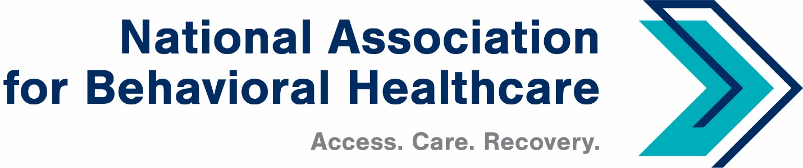
NABH Executive Committee Call
Monday, Sept. 12, 2022
Minutes

Roll Call
Present: Members: Matt Peterson, Board Chair; Mark Covall, Frank Ghinassi, Pat Hammer,
John Hollinsworth, Eric Kim, Jameson Norton, Eric Paul, Harsh Trivedi

Staff: Shawn Coughlin, Julia Richardson, Emily Wilkins, Jessica Zigmond

Absent: Matt Peterson, Board Chair; Frank Ghinassi, Eric Paul, Sarah Wattenberg

- Minutes Approval: Aug. 8 Executive Committee Call
Harsh approved and Mark seconded the minutes. All members approved the minutes unanimously.

- NABH EVP for Government Relations and Public Policy
Shawn said he was pleased to report that Rochelle Archuleta started on Sept. 6 as the association’s new executive vice president for government relations and public policy.

Rochelle brings with her more than 30 years of experience in healthcare policy and came to NABH after 20 years at the American Hospital Association. NABH announced Rochelle’s new position in an internal NABH Alert, a news release, on social media, and in CEO Update.

- Regulatory Update
Shawn reminded EC members that NABH has submitted public comments to the Centers for Medicare & Medicaid Services regarding the agency’s proposed rules for the inpatient psychiatric facility prospective payment system (IPF-PPS) and the Physician Fee Schedule. Shawn added that NABH will submit comments on the Outpatient Prospective Payment System (OPPS) rule tomorrow, Tuesday, Sept. 13.

- Legislative Update
Shawn reported that both the House and Senate have returned from the August recess. Members will now focus on a continuing resolution (CR) to fund federal government operations after Sept. 30. This bill is likely to fund the government through early December 2022.

Shawn added that there is discussion about using the FDA user fee authorization act as part of this bill.

There are several behavioral health issues in play, including several provisions in the SUPPORT Act that are set to expire on Sept. 30. Shawn said it’s likely that an end-of-hear legislative package is the most likely place where these provisions will appear.

Shawn added that Congress may consider an end-of-year legislative package during the lame duck session, which will convene after the mid-term elections.

In addition, Medicare PAYGO/sequestration cuts are still in consideration, but have not been considered “must pass” as part of the CR effort and may receive attention in the end-of-year package. Shawn added the following details:

- 2% Medicare sequestration cut: This was put on hold during the pandemic but began phasing back in on July 1, 2022; it will likely be allowed to continue.
- 4% PAYGO sequestration, which was scheduled for January 2022; however, Congress delayed it for one year: There is bipartisan support for addressing this and discussions are ongoing.
- A combined 6% cut would be the highest allowed under current law: if this were to take effect, it would last through FY 2031.
- Also of note: the temporary 3.75 % conversion factor for Medicare Part B services in the Medicare Physician Fee Schedule in FY 2021 was extended and reduced to 3% starting in January; this is also set to expire at the end of December. If allowed to expire, this would bring the total payment cut for many providers to 9%. Shawn said to expect a lot of attention on these issues, which could drive legislation action.

Meanwhile, Shawn reported that Congress is also discussing the possibility of extending telehealth flexibilities under the Covid-19 public health emergency (PHE). CMS has taken some steps toward extending in its proposed rules and there are several bills in Congress with bipartisan support that are likely to see action by the end of this congressional session.

Shawn cautioned that these possibilities are flexible now that Members of Congress have returned from the August recess and are considering the CR.

- NABH 2022 Membership Directory: Member Updates
Shawn reminded EC members about the membership update survey and that NABH extended the deadline for members to submit their information by Friday, Sept. 16. As a reminder, in August NABH sent members a message with a link to the association's membership-update tool.

NABH has added several new categories this year, and the answers to these questions will help the association provide a more accurate description of our diverse membership to policymakers, regulators, partner organizations, and the media.

- Updated CEO Alliance for Mental Health Unified Vision
Shawn reminded members that the CEO Alliance for Mental Health—of which NABH is a member organization— in late August released an updated Unified Vision for Transforming Mental Health and Substance Use Care for 2022. NABH reported this to members in the Aug. 26 issue of CEO Update.

Click here for the updated vision, which includes information related to the national 988 behavioral health crisis line that launched in July.

- AHIP Discussion
Shawn reported that he an initial conversation with representatives from America’s Health Insurance Plans (AHIP) about issues that NABH and AHIP could work on collaboratively.

- Residential Treatment Facilities
Shawn said three NABH members received a request for information from Sens. Ron Wyden (D-Ore.) and Patty Murray (D-Wash.) regarding their inquiry about residential treatment facilities, particularly those that provide treatment to youth. In addition, NABH is working on a draft response to the inquiry.

Shawn also said NABH learned there is a new version of a draft bill-- The Stop Institutional Child Abuse Act—that was developed after news reports and heightened media coverage related to Paris Hilton.

There were no questions from members and Shawn adjourned the call.

