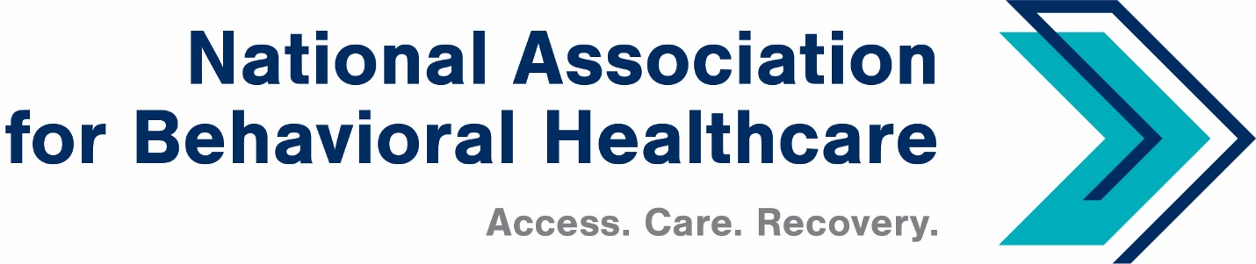
NABH Executive Committee Call
Monday, Feb. 14, 2022
Minutes

Roll Call
Present: Members: Matt Peterson, Board Chair; Mark Covall, Frank A. Ghinassi, Pat Hammer, John Hollinsworth, Jameson Norton, Eric Paul, Francis Sauvageau, Harsh K. Trivedi

Staff: Shawn Coughlin, Kirsten Beronio, Maria Merlie, Julia Richardson,

- Welcome/Minutes Approval
Shawn began the call at 3 p.m. and welcome all new members to the Executive Committee. He also thanked Jameson Norton for his service and welcomed Matt Peterson.

A motion was made and seconded to approve the December EC call minutes. Members approved Minutes Approval: Dec. 13 Executive Committee Call.

- Year-End Financials
Shawn said net operating income was $316,000. NABH transferred $200,000 to the association’s Education & Research Foundation. With investment income, total net income for NABH was $561,672. Budgeted net income was $153,874.

Frank Ghinassi performance was strong. Financials as reported were optimistic, and investments were sounded. Frank added that he thinks the association handled investments in a sound manner.

There were no questions about the financials.

- Legislative Update
The current Continuing Resolution runs through March 11 (passed last week) and there is talk of a bipartisan, bicameral omnibus package.

There is a lot of activity associated related provisions to include in that must-pass omnibus bill and then there will be fewer opportunities to pass legislation as we approach the mid-term elections.

Shawn reported that in late January, HHS and the Labor and Treasury Departments published a report finding health insurers were widely noncompliant with mental health coverage parity laws. Current law requires that any financial or treatment requirements imposed by payers, such as copayments or prior authorization requirements, on mental health or SUD benefits aren't allowed to be more restrictive than those imposed on all other medical or surgical benefits.

No plans analyzed by the federal government were compliant with the law. The report called for Congress to give the Labor Department more power to enforce parity laws. One enforcement measure on the table is giving regulators civil monetary penalties, allowing them to fine any plans with illegal barriers to mental health and SUD benefits. Civil monetary penalties were included in the Build Back Better Act.

The current Public Health Emergency (PHE) is in effect until April 16. There is talk of including additional Provider Relief Funds in the omnibus package.

Shawn reported that NABH is seeing activity in both the House and Senate about behavioral healthcare. The Senate Finance Committee is working to address problems with the nation’s mental health crisis. The committee hopes to draft legislation by this summer. NABH submitted comments as a response to the Senate Finance Committee’s RFI last week.

The committee recently held a hearing that featured U.S. Surgeon General Vivek Murthy, M.D., who discussed youth mental healthcare.

The co-chairs will work together and with committee staff on a bipartisan basis to identify legislative steps to improve the mental health care system.

The Senate Committee on Health, Education, Labor, and Pensions (HELP) held a hearing on the U.S. mental health crisis on Feb. 1: Mental Health and Substance Use Disorders: Responding to the Growing Crisis

On Feb. 10, the HELP Committee held a hearing to discuss ways to bolster recruitment, retention, and diversification within the health care workforce in light of the shortage facing the industry.

Regarding workforce: Legislators agreed that bolstering the workforce was a top priority for addressing the nation's mental health obstacles.

Shawn noted that the House Ways and Means Committee and House Energy and Committee are a little behind the process compared with the Senate, but they are paying attention to the issue and announced hearings.

House Ways and Means committee hearing on Feb. 2 regarding the nation’s mental health crisis.

The House Energy and Commerce Committee’s Oversight and Investigations Subcommittee will hold a hearing on the mental health challenges facing Americans on Feb. 17.

Provider Relief Fund Improvement Act: Sens. Shaheen (D-N.H.) and Collins (R-Maine) introduced legislation that builds on their bipartisan work to bolster the Provider Relief Fund

Telehealth Services: Absent another extension of the PHE, Medicare beneficiaries would be slated to lose access to telehealth services immediately. The Senators are hoping that the language can be attached to the potential omnibus that appropriators are working to complete.

Medicare Cuts: Coalition to Protect America’s Health Care released add opposing cuts. NABH has supported this and promoted it on the association’s Twitter and LinkedIn platforms.

No Surprises Act: Shawn said NABH signed a letter with 11 organizations regarding the IFR about the No Surprises Act to exempt behavioral health providers from rules announced last year. NABH’s position is that the regulations affect behavioral health providers are more burdensome than they are for other providers.

- Regulatory Update
Kirsten Beronio reported that NABH continues to advocate for behavioral healthcare providers to implement health IT in ERs. Psych hospitals were excluded from subsidies included in the HITECH Act in 2009. We are involved in a coalition to work on this issue and we will meet with CMS this Friday, where Kirsten will represent providers. Kirsten said there are rumors that this will be included in President Biden’s budget.

NABH is also working on implementation for the toll-free, 988 hotline that will take effect in July 2022. Kirsten has been working about raising awareness with SAMHSA that it should include behavioral healthcare providers in the department’s thinking about the response from the hotline and linking providers to crisis stabilization services. Kirsten added that NABH, including with Board-Chair Elect Harsh Trivedi, will meet with SAMHSA about this later this week.

NABH submitted comments in January regarding network adequacy requirements in the federally qualified health plans on the insurance exchanges.

In addition, CMS has released an RFI regarding network adequacy and Medicare managed care plans.

Sarah Wattenberg discussed contingency management (CM), an intervention for people who use stimulants. CM never took off because of an OIG opinion in 2008 that warned providers about fraud related to CM without clear guidance about the effectiveness of CM.

Sarah said a good portion of overdose deaths is from meth, and the co-use of opioid use and meth is also on the rise. Sarah is part of a policy group that has lobbied the government for the broad implementation of CM. We have had success, meeting with top administration officials; there has been a positive OIG report; HHS has established work group on this; ONDCP established an inter-agency workgroup with other agencies—such as DOJ and IRS—for which CM has implications.

Sarah said she will publish an editorial in ASAM Weekly about CM.

NABH staff members disconnected from the call at 3:47 p.m. so EC members could begin an Executive Session to discuss staff bonuses.

