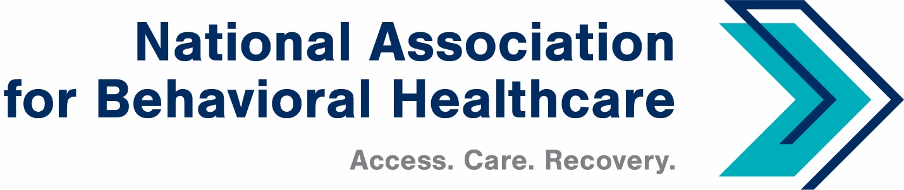
NABH Executive Committee Call
Monday, Dec. 12, 2022
Minutes

Roll Call
Present: Members: Mark Covall, Frank Ghinassi, Pat Hammer, Eric Kim, Jameson Norton,
Eric Paul, Harsh Trivedi

Staff: Shawn Coughlin, Rochelle Archuleta, Maria Merlie, Julia Richardson, Emily Wilkins, Sarah Wattenberg, Jessica Zigmond

Absent: Matt Peterson, Board Chair; John Hollinsworth

- 2023 Budget
Shawn Coughlin began the call discussing the proposed 2023 budget. He said NABH will finish 2022 with a surplus of $293,302.

Shawn added that the association had a good year on solid footing. Shawn said we are seeing solid growth in membership and the average dues of members is increasing.

Shawn said the pandemic has affected the Annual Meeting in the last few years, so we lowered our projections. We have seen an uptick in attendance, and there remains strong interest among exhibitors and sponsors to participate. The association has started planning for the 2023 Annual Meeting and will consider where we can save expenses.

Shawn said staff salaries, office rent, and other fixed costs remain stable. Shawn highlighted the following items in the budget:

- Dues Estimates: NABH members have grown considerably, and, consequently, the number highlighted in green may increase later in the year.

- IPF-PPS: We have set aside a significant investment here: $200,000 for resources to engage in developing our position on this issue. NABH has set that money aside and sent RFIs to a few groups, for which Dobson & DaVanzo took interest.

- Because NABH hired Rochelle Archuleta as the new EVP, we can bring lobbying back in-house. That was essentially a $196,000 expense that the association can divert to the IPF-PPS effort.

Mark Covall will retain his seat on the board and paid consultancy to NABH: $85,000 for 2023.

Shawn added that investments remain solid and that the association’s financial advisors recommend that NABH stay the course and not make major changes to investments. Reserves are there, if needed; however, Shawn said we do not anticipate needing to call upon those reserves.

NABH Treasurer Frank Ghinassi concurred and said the portfolio looks healthy and the investors made a clear rationale for staying the course. Frank added that he is confident in the association’s financial standing.

Pat Hammer asked if cash assets are still strong. Shawn said yes. Pat added that this puts the association in a strong position financially.

Shawn asked NABH Board Chair-Elect Harsh Trivedi for a motion. Harsh asked for a motion to approve the 2023 budget. Pat Hammer moved, Mark Covall seconded, and members voted unanimously to approve the budget.

- 2022 Legislative Wrap-up
Shawn said there has been talk of either another short-term omnibus bill or a long-term Continuing Resolution to fund the government.

Shawn said there remains broad, bipartisan support against Medicare cuts to providers. He said there is a strong likelihood to address these cuts, including either delaying or reducing the cuts, although not eliminating them.

Shawn said HR7666 approved reauthorizations for both SAMHSA and HRSA, so there is strong likelihood that the full Congress will approve those and reauthorize those agencies and their respective programs.

Shawn said we do not expect a significant reallocation on the Senate side; however, the news late last week that Sen. Kyrsten Sinema’s switch to Independent from Democrat status marks a one-seat change.

In the House, there will be a dramatic re-alignment in the House Energy and Commerce Committee, with 25 new people on it.

- 2022 Regulatory Wrap-up
CMS released its Medicare prior authorization rule, which was favorable to NABH’s interest and included all public healthcare programs. We informed members about this and other details in the Dec. 9 edition of CEO Update.

The NABH Education and Research Foundation, in conjunction with research firm Manatt, on member interview data regarding telehealth.

- 2023 Congressional Outlook
Shawn said Sens. Wyden and Crapo will remain the chair and ranking members, respectively, of the Senate Finance Committee, while NABH Champion Sen. Bill Cassidy will serve as chair of the Senate HELP Committee with Sen. Bernie Sanders as the ranking member.

In the House, Cathy McMorris Rodgers will chair the Energy and Commerce Committee and Brent Guthrie will be the chair of the E&C Health Subcommittee.

Shawn said he spoke recently with Rep. Cathy McMorris Rodgers, who said there is a strong belief that there are tens of billions of dollars in unused Covid-relief funds. So to the degree that these funds are available, the House will work to recapture those, as opposed to issuing new domestic spending.

- Government Relations Network
An outgrowth of the NABH Government Relations Database, NABH has identified 58 government relations contacts within the members. Now NABH staff is looking to better coordinate efforts and to develop a dashboard on key issues and toolkits with issue briefs.

There were no questions from members and Shawn adjourned the call at 3:32 p.m. ET.

