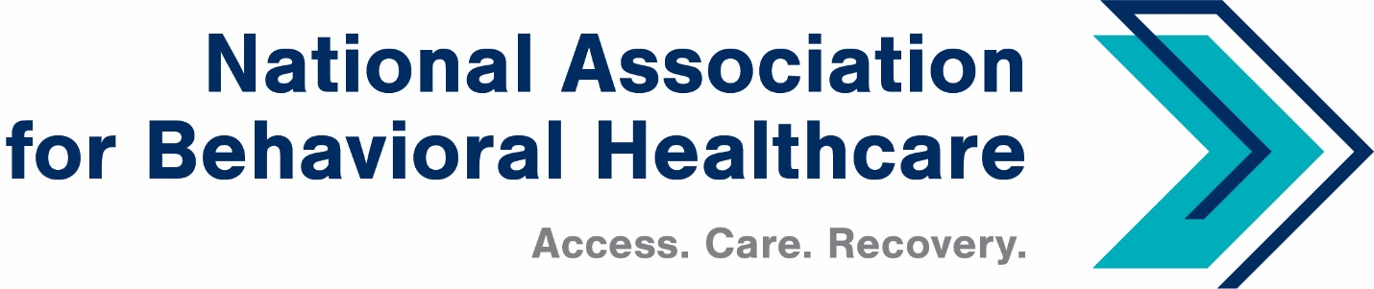
Board of Trustees Call
Monday, Jan. 30, 2023
Minutes

Roll Call
Present: Members: Stuart Archer, John Boyd, Thomas Britton, Deborah Brodine, Pat Connell,
Mark Covall, Frank Ghinassi, John Hollinsworth, Tess Hughes, Richard Kresch,
Dwight Lacy, Drew Martin, Jameson Norton, Eric Paul, Ethan Permenter, Matt Peterson, Scott Rauch, Harsh Trivedi, Brent Turner, David White, Jeffrey Woods, Susan Wright

Staff: Shawn Coughlin, Rochelle Archuleta, Maria Merlie, Julia Richardson,
Sarah Wattenberg, Emily Wilkins

Absent: Members: Tom Kenny, Eric Kim, Hank Milius, Joe Pritchard, Jim Shaheen, Hyong Un, Sean Walsh, Deborah Weidner, Jessica Zigmond (Staff)
Introduction/New Board Members
Shawn Coughlin began the call at 2:03 p.m. ET, took attendance, and welcomed new board members. Shawn also acknowledged Harsh Trivedi as the new Board Chair. Harsh said he looks forward to being the Board Chair this year and working with everyone.
Approval of the 2023 Executive Committee
NABH provided the slate of new officers to board members prior to the call. Shawn said this slate represents the membership’s diversity. Pat Connell moved to approve the slate and Hank Milius seconded. All members approved the slate.
Ongoing activities
Shawn updated the board with the association’s ongoing activities. The House and Senate are starting to announce their committee assignments. Internally, the NABH staff is working to match NABH champions with the Members of Congress on the relevant congressional committees.
NABH is looking to identify both existing and new potential champions in the House Energy and Commerce and House Ways and Means Health Subcommittees, and the Senate Finance and HELP Committees. NABH will contact members of the Government Relations Task Force. NABH’s government relations contacts have increased dramatically. We will schedule a call with that group to share our priorities and provide them with our advocacy materials and toolkits and initiatives for our PAC activities. We will also support our members through site visits with Members of Congress.
Mark Covall applauded Shawn for expanding this advocacy platform, which the association has worked on for some time.
Stuart Archer informed the board that he had breakfast with Sen. Bill Cassidy, M.D. (R-La.) and that he echoed the approach of NABH. Stuart said he is happy to help with anything.
Shawn then discussed the current outlook on Capitol Hill. The House Energy and Commerce is holding hearings on the nation’s fentanyl crisis, a suicide lifelines breach, and discrimination against individuals with disabilities. Shawn said he hopes the Covid pandemic crisis is behind us and that the public health emergency (PHE) has been extended one last time. The end of the PHE means Congress can focus on the issues important to NABH. NABH is working on the preauthorization for the SUPPORT Act, provisions of which expire in September.
House Energy and Commerce Committee Chair Cathy McMorris Rodgers (R-Wash.) and Rep. Mike Burgess, M.D. (R-Texas) contacted NABH regarding the IMD repeal. NABH is working with the congressional leaders and providing background information. The Chairwoman believes it should be included in the bill.
Shawn said that he will update the Executive Committee and the board of upcoming hearings.
NABH is in the process of commenting on three proposed rules: the Affordable Care Act state and federal marketplaces; Medicare Advantage; and electronic prior authorization. NABH hosted a Managed Care Committee call, and the team is finalizing comments on the Medicare Advantage rule. Comments are due Feb. 13, 2023.
Comments for the electronic prior authorizations are due in March. Shawn asked board members if they are able to submit prior authorizations.
Deborah Brodine from UPMC said her system doesn’t have concerns about submitting; however, UPMC is concerned about standardization. Susan Wright from BayCare agreed with Deborah and said systems should handle standardization. Board members should contact Shawn if they have follow-up questions or concerns about this issue.
Shawn said the NABH Program Committee has met and approved our theme for the annual meeting: Securing the Promise of Parity, which recognizes the15th anniversary of the Mental Health Parity and Addiction Equity Act. NABH will also highlight the association’s 90th anniversary this year. This year’s annual meeting will recognize both.
Finally, a three-judge panel in the 9th U.S. Circuit Court of Appeals re-issued a brief on the Wit v. UBH ruling last week. Meiram Bendat is examining the ruling and not ready to comment. NABH will share its comments about the ruling with the NABH Executive Committee and Board of Trustees in the future.
The meeting adjourned at 2:27 p.m. ET.

