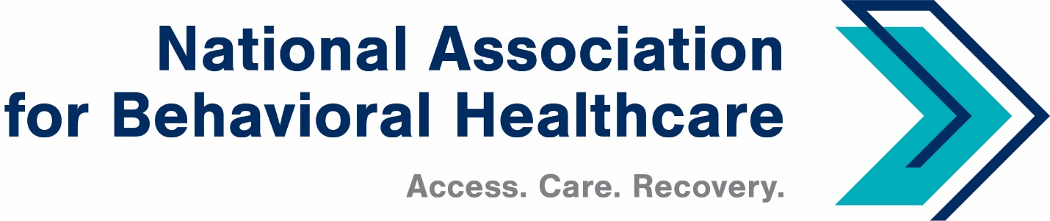
Board of Trustees
Thursday, Jan. 27, 2022
Minutes

Roll Call
Present: Members: Matt Peterson, Board Chair; JP Christen, Pat Connell, Mark Covall, Eric Foushee, Pat Hammer, Richard Kresch, Drew Martin, Andrew McWilliams, Hank Milius, Eric Paul, Ethan Permenter, Fran Sauvageau, Harsh Trivedi, Sean Walsh, Susan Wright
Staff: Shawn Coughlin, Kirsten Beronio, Maria Merlie, Julia Richardson,
Sarah Wattenberg, Emily Wilkins

Absent: Stuart Archer, Matt Feehery, Frank Ghinassi, John Hollinsworth, Eric Kim, Dwight Lacy, Joe Pritchard, Michael Radosta, Scott Rauch, Deborah Weidner, Jessica Zigmond (Staff)
Introduction/New Board Members
Shawn Coughlin began the call at 3 p.m. ET, took attendance, and welcomed new board members.
Shawn reviewed the slate of new officers and Mark Covall moved to approve the slate. It was seconded and all members approved.
Legislative Update
Shawn updated the board with legislative activities. The Senate Finance Committee, House Ways and Means Committee, and House Education and Labor Committee are hosting hearings on behavioral health initiatives.
NABH is waiting to learn about another legislative Covid relief package with a focus on workforce. Shawn reported that we are expecting another Continuing Resolution (CR) or omnibus appropriations package to continue funding federal government agencies and programs.
There is potentially a provision to delay sequestration of Medicare cuts of 2% beyond the delay to April that was enacted at the end of last year. NABH hopes that sequestration is delayed during the continuing public health emergency. Finally, there is a continuation of the Covid-19 public health emergency through mid-April and the opioid public health crisis until early April.
Regulatory Update
NABH Director of Policy and Regulatory Affairs Kirsten Beronio reported there has been another distribution of the Provider Relief Fund (PRF) of about $2 billion focused on underserved communities. The NABH team thinks this is the last round of funding unless Congress provides additional funds.
The Supreme Court issued a stay on the vaccine-or-testing mandate from the Occupational Safety and Health Administration (OSHA) regarding Covid vaccinations for employees and upheld the Center for Medicare & Medicaid Services’ (CMS) requirements for vaccination among personnel in healthcare facilities.
Kirsten said NABH will include the deadlines for compliance with the CMS rules in CEO Update. On the issue of parity, the U.S. Labor (DOL), Treasury, and Health and Human Services Departments issued a report to Congress noting the widespread lack of compliance with recently enacted requirements to document compliance with parity. This report included several legislative recommendations including authority for DOL to assess civil penalties for parity violations and imposition of parity requirements on third party administrators.
NABH continues to raise questions about the interim final rule regarding surprise medical billing. Finally, Kirsten reported that NABH will submit comments to CMS on a proposed rule that includes network adequacy standards for qualified health plans offered in the federally regulated health insurance exchanges.
NABH Director of Quality and Addiction Services Sarah Wattenberg reported that New Mexico has claimed that opioid treatment programs (OTPs) are subject to the new vaccine rules. Sarah confirmed that OTPs are not subject to those rules. CMS released a series of guidance documents to help providers see if they are subject to the agency’s vaccination requirements.
Before closing the meeting, Shawn updated the board on the theme for the next Annual Meeting: Shaping the Future of Behavioral Healthcare.

